UNIVERSITY OF PALERMO

MSc Degree Course in Electronics Engineering

APPLIED ELECTRONICS

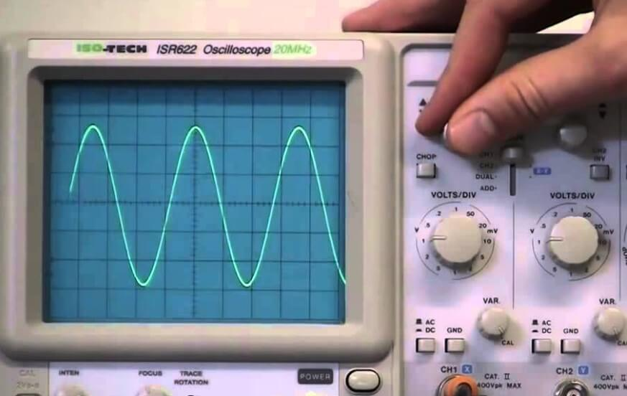

Mustafa Yagci
Matricola: 0830177

Experimental #1

Closed-Loop Two-Transistor Voltage Regulator

Circuit overview
The circuit under test is the series-parallel negative-feedback regulator made of:
- Q1 (BD139): series pass transistor
- Q2 (2N2222): error amplifier comparing feedback voltage vs. Zener reference
- Zener diode providing the reference voltage
- Feedback divider (R3– R4) sampling the output
- Input capacitors improving stability
In this circuit, the output voltage Vo is sampled by a voltage divider formed by R3 and R4, establishing a feedback factor 𝛽 =R4/R3+R4. The output from the divider serves as the feedback
voltage which is "subtracted" from the control voltage (i.e., the VZ across the Zener diode) through transistor Q2. The collector voltage of Q2 thus provides the input voltage Vi to our unity-gain follower amplifier. Capacitor C1 is included to narrow the amplifier's bandwidth, enhancing stability.
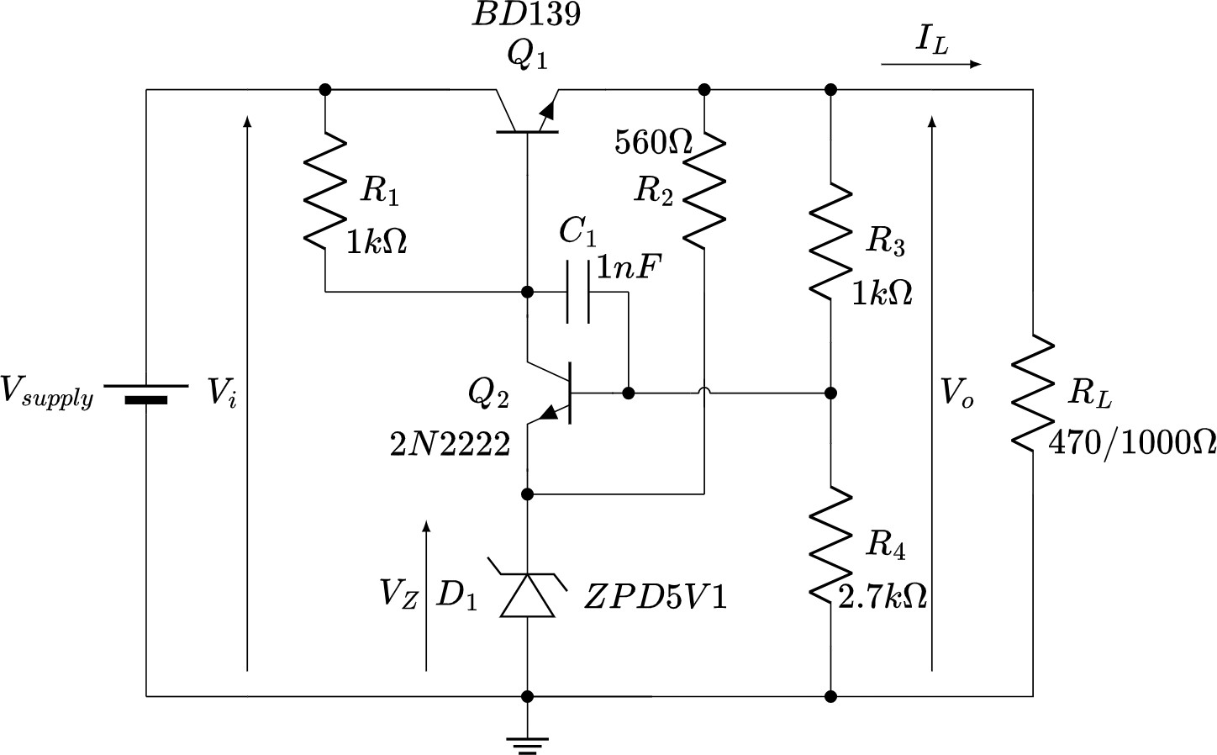

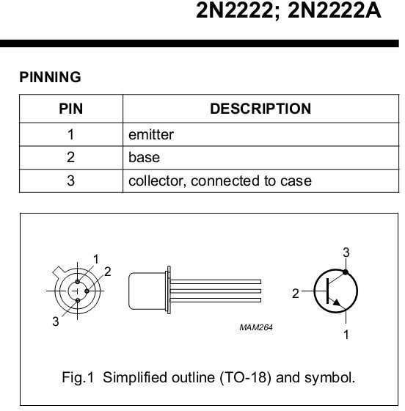


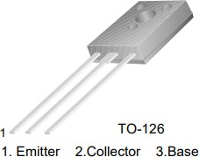

Measurements

Objective:
Quantify how the output voltage changes when the input voltage varies.

Procedure:
- Set a fixed load resistor and measure its value through the multimeter.
- Apply 12 V at the input and measure: input voltage output voltage, Zener voltage (record all the displayed digits).
- Increase the input to 15 V and repeat the measurements.
- Change the resistor value and repeat from point 2.

Calculation:

Evaluate the input voltage sensitivity as: 𝑆_{𝑉}𝑖 = Δ𝑉O/Δ𝑉İ expect a small value for the feedback regulator
Compute the load current through the Ohm’s law
Evaluate the regulator output resistance (load current sensitivity) 𝑆_{𝐼}𝐿 = Δ𝑉O/ Δ𝐼𝐿
Compute the efficiency 𝜂 = 𝑉O/𝑉İ

Measurements:

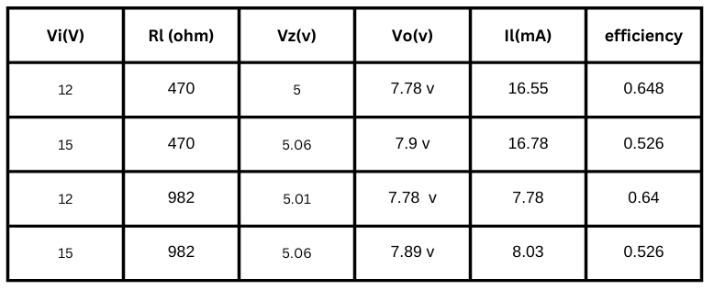
Line Regulation (Input Sensitivity)
SVI=0.04 for RL= 470
SVI=0.037 for RL= 982

Load Current and Output Resistance (Load Regulation)

with Vi =12 , SIL =0
with Vi =15 , SIL =1.14
Low output resistance indicates good load regulation.
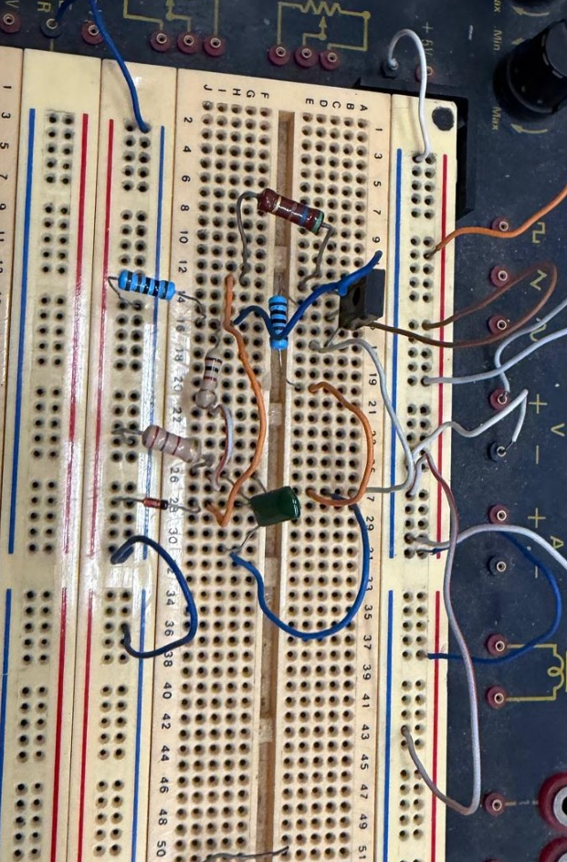

Zener Diode Characterization
Circuit overview:
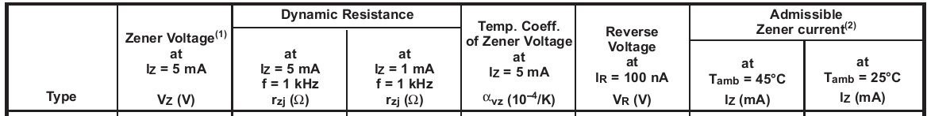
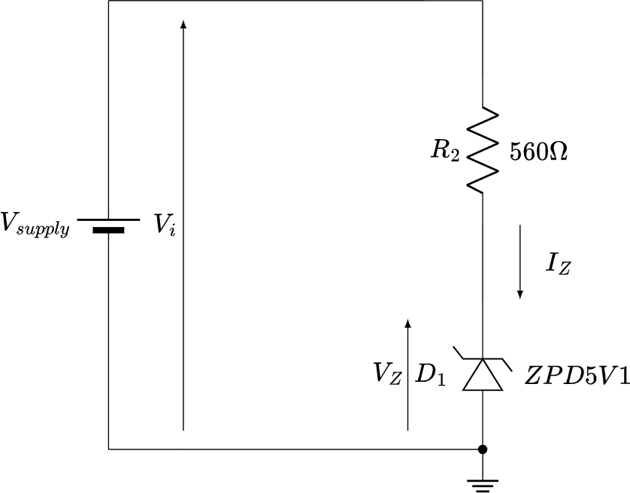
The circuit to build is shown in Figure 3. It is a simple Zener diode biasing network, consisting of the variable panel power supply, a resistor, and the diode. Figure 4 shows the main characteristics of the Zener diode. The goal of this phase of the exercise is to verify the breakdown condition of the Zener diode and to measure the voltage across the Zener and the current flowing through it as the power supply voltage varies from +12V to +15V. This allows us to determine the Zener's dynamic resistance under breakdown conditions.

Measurements zener diode:
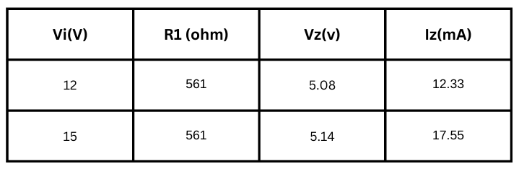
RZ = 11.49 Ω
Conclusion:

In this experiment, we observed how negative feedback improves the voltage stability of a linear regulator. By measuring the line regulation, load regulation, and Zener dynamic resistance, we were able to evaluate the regulator’s performance under different input voltage and load conditions. The experiment also showed that the Zener diode is not an ideal voltage reference and that its voltage changes slightly depending on the operating conditions.

Experimental #3

Narrow-band amplifier as a Mixer

Circuit overview
The board (see Fig.1 for the schematic) includes an NPN BF200 transistor amplifier (see Fig. 2 for the datasheet) and an adjustable transformer with ferrite screw. By adjusting the screw, the inductance changes, allowing fine tuning of the resonance frequency. The amplifier behaves as a narrow-band selective circuit, providing maximum gain near its resonance frequency while attenuating other frequencies.
Two signal generators provide the input signals: the local oscillator (LO) and the radio-frequency (RF) input.

Background
A narrow-band selective amplifier amplifies signals only within a specific narrow frequency range. This makes it useful in communication systems such as radio receivers. In this experiment, the amplifier is used as a mixer.
A mixer is a nonlinear circuit that combines two input signals to produce new frequencies equal to the sum and the difference of the original frequencies.
Here, a 2 MHz square wave serves as the LO signal and a 1.5 MHz sine wave serves as the RF signal. The resulting IF signal is 500 kHz, which is the difference between the two input frequencies.
You will also analyze the output signal and observe nonlinearities and harmonic components.
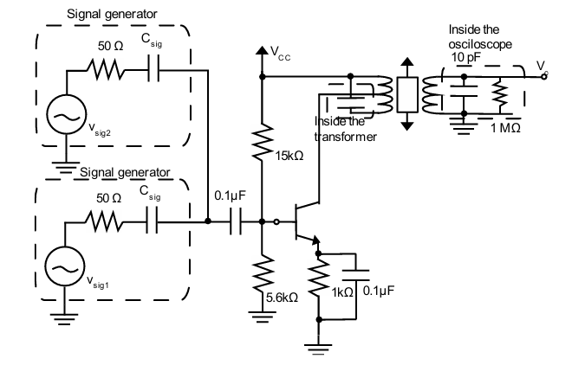

Experimental Instructions

Filter tuning:
- Set the waveform generator to 500 kHz sine wave, amplitude 10 mVpp.
- Adjust the ferrite screw until the output amplitude reaches its maximum value.
- Record the output amplitude and the corresponding gain.

3 dB bandwidth measurement:
- Vary the input frequency around the resonance value.
- Identify the upper and lower frequencies where the output amplitude drops to 70% of its maximum value (1/√2).
- Calculate the bandwidth as the difference between upper and lower frequencies.

Quality factor Q:
- Compute Q as the ratio between resonance frequency and the 3 dB bandwidth.
- Record the obtained value.

Observation of non-linearity:
- Set the oscilloscope in XY mode.
- Increase the input amplitude gradually.
- Observe non-linear distortion on the displayed curve.

Mixing of two input signals:
- Apply a 2 MHz square wave as LO input.
- Apply a 1.5 MHz sine wave as RF input.
- Observe the IF signal at 500 kHz at the amplifier output.
- Observe the sum frequency component.
- Analyze the output spectrum.

Experimental Results :
Resonance frequency: ≈ 500 kHz
Lower cutoff frequency: 469,1 kHz
Upper cutoff frequency: 510,1 kHz
3 dB bandwidth: 510,1 - 469,1 = 14 kHz
Quality factor Q: (500 KHz / 14 KHz ) ≈ 35

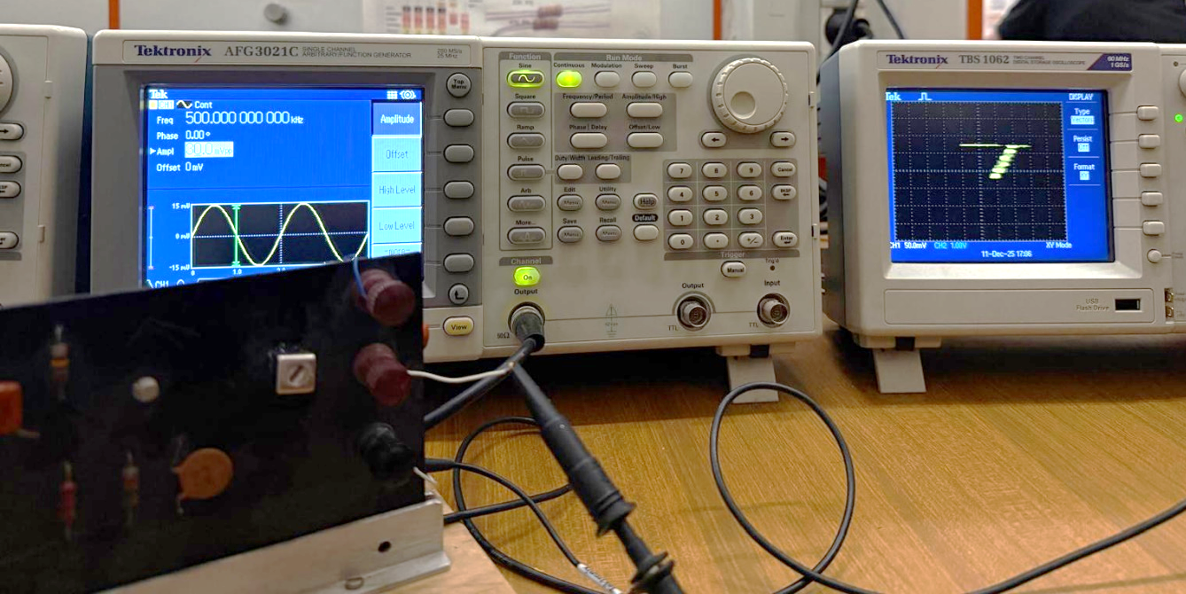

Conclusion:

In this experiment, we studied the behavior of a narrow-band selective amplifier and adjusted it to operate around its resonance frequency. We measured its resonance frequency and bandwidth, and used these results to evaluate the quality factor. We also observed the nonlinear behavior of the amplifier and used it for frequency mixing. The results helped us understand how mixing works and how it is used in communication systems, especially in radio receivers.

Experimental #4

Phase-Locked Loop

Circuit overview
The ASLK PRO board integrates all the blocks required to implement a Phase-Locked Loop, including a phase detector, a low-pass filter, a voltage-controlled oscillator, and output buffers. An implementation is depicted in Fig. 1. The PLL structure, as summarized by Fig. 2, allows the output frequency to synchronize with an external input signal.
When no input signal is applied, the VCO oscillates at its free-running frequency with a corresponding control voltage. When an input signal is applied near this frequency, the PLL adjusts the control voltage to lock the output frequency to the input frequency, producing a fixed phase difference between the two signals.

Background
A Phase-Locked Loop is a feedback system commonly used for frequency synthesis and clock generation. Starting from a low-frequency reference, a PLL can generate stable signals at much higher frequencies.
When the input frequency equals the free-running frequency of the VCO, the PLL operates without adjusting the control voltage, and the phase difference between input and output is approximately 90 degrees.
As the input frequency changes, the PLL modifies the VCO control voltage to maintain frequency lock, causing the phase difference to deviate from 90 degrees.
The range of input frequencies for which the PLL remains locked is defined as the lock range, centered around the free-running frequency.

Key concepts
- Phase Detector: Compares the phase of the input signal with the VCO output and produces an error signal.
- Low Pass Filter: Removes high-frequency components from the phase detector output.
- Voltage-Controlled Oscillator: Generates an output frequency controlled by the filtered error voltage.
- Free-running frequency: Natural oscillation frequency of the VCO without input signal.
- Lock range: Frequency range over which the PLL remains locked after lock is achieved.
- Capture range: Frequency range over which the PLL can initially achieve lock.
- Harmonic locking: Condition in which the PLL locks to an integer multiple of the input frequency, typically caused by strong harmonic content in the input signal.

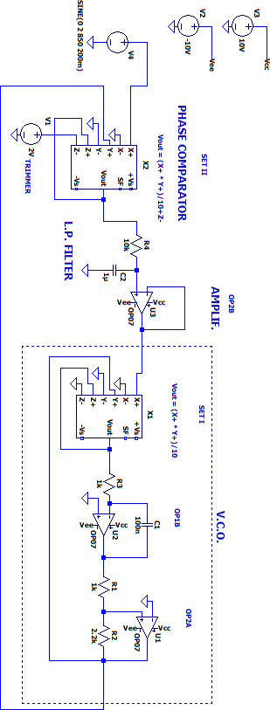
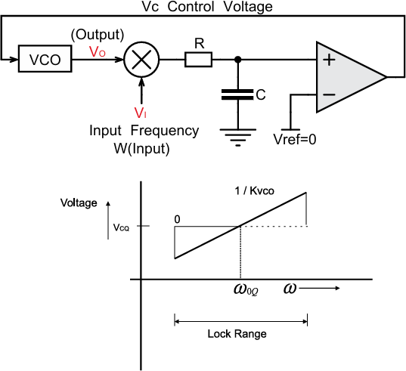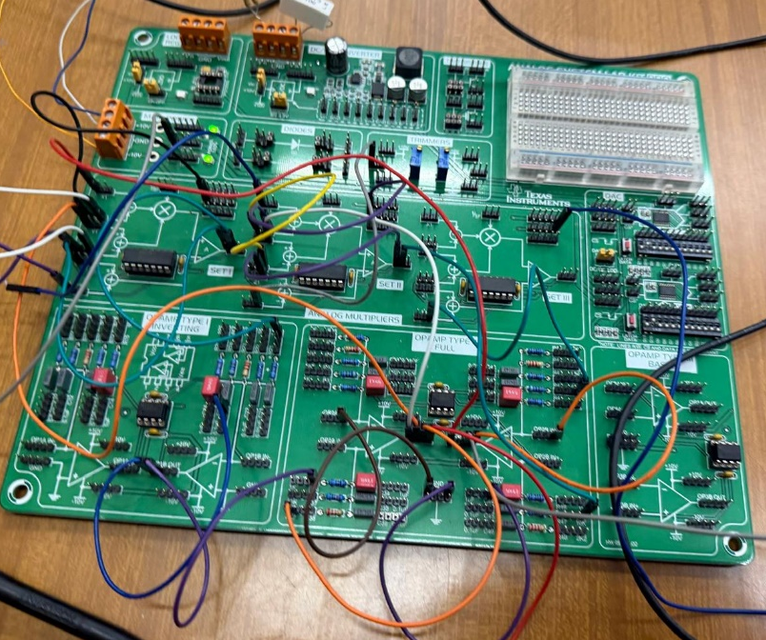

Experimental Instructions

Offset tuning:
- Verify if the trimmer S1 is generating 2V.
- If needed, adjust the trimmer screw until the measured DC voltage equals 2 V.

Verification of lock:
- Set the signal generator to produce a sine wave with amplitude 4 Volts peak-to-peak and frequency 1.1 kHz.
- Observe the PLL output signal and verify that the system is locked to the input frequency.

Lock range measurement
- Increase the input frequency incrementally and record the frequency at which the PLL loses lock.
- Decrease the input frequency incrementally and record the frequency at which lock is lost again.
- Determine the upper and lower limits of the lock range.

VCO control voltage and phase measurement:
- Within the lock range, vary the input frequency.
- Measure the VCO control voltage at the output of operational amplifier OP2B.
- Measure the phase difference between input and output signals.
- Plot the VCO control voltage as a function of input frequency.
- Analyze the relationship between control voltage variation and phase shift.

Harmonic locking:
- Set the signal generator to output a square wave with frequency 300 Hz and amplitude 6 Volts peak-to-peak.
- Observe whether the PLL locks and determine the output frequency.
- Identify the harmonic responsible for locking.

Follow-up question:
- Explain why harmonic locking occurs when using a square wave input and not when using a sinusoidal input.

Experimental Results:
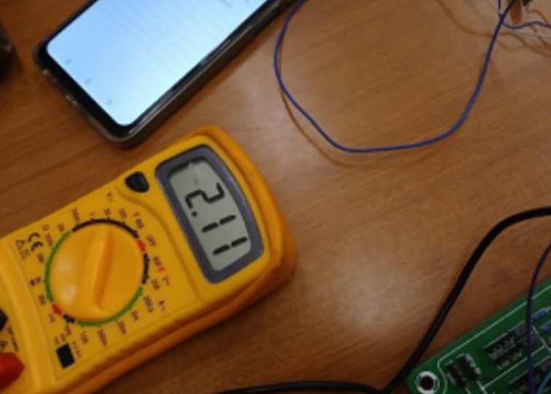 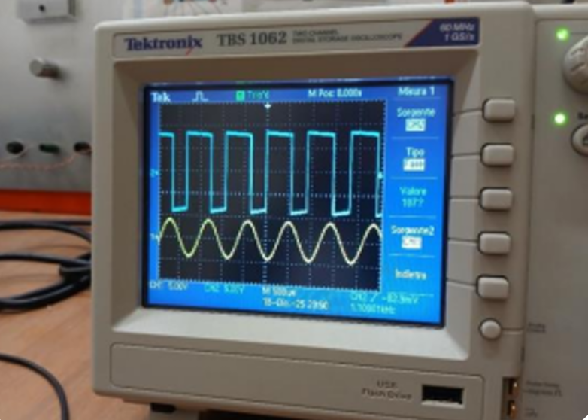
Locked state verification at 1.1 kHz.
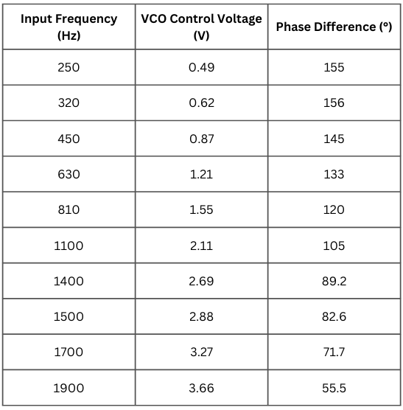
Harmonic Locking Analysis

To observe harmonic locking, we changed the input signal from a sine wave to a square wave with a frequency of 300 Hz and an amplitude of 6 V peak-to-peak. After this change, we observed that the PLL output locked at around 900 Hz.

This happens because a square wave contains several harmonic components, especially odd harmonics. Since the third harmonic of the 300 Hz input signal is 900 Hz, which is close to the VCO free-running frequency, the PLL locks onto this harmonic instead of the fundamental frequency. With a sine wave, this behavior is not observed because a pure sine wave contains only one frequency component.
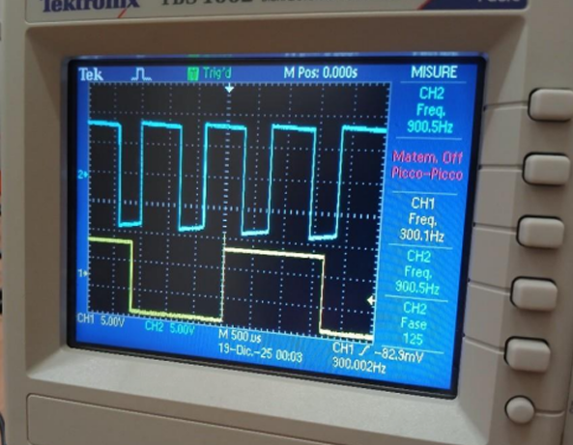

Conclusion:

In this experiment, we studied the basic operation and behavior of a Phase-Locked Loop (PLL). We observed that the PLL was able to synchronize its output frequency and phase with the input signal within a certain lock range.

The measurements showed that the input frequency, VCO control voltage, and phase difference are closely related. As the input frequency increased, the control voltage also changed to keep the PLL locked. We also observed that the phase difference became smaller near the center of the lock range.

The harmonic locking test showed that the shape of the input signal can affect the behavior of the PLL. When a square wave was used, the PLL was able to lock onto one of its harmonic frequencies. Overall, the experiment helped us better understand how a PLL works in practice and how its behavior can change depending on the input signal.

